Activities to do with your children
Learning
- Matching
- socks
- shoes
- cutlery
- match kokies with other colours in the house
- Counting: - Rote counting is just counting from 0 up …
- Touch – counting is touching each object as you say the number
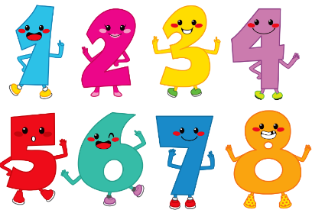
- 1 -1 counting is lifting an object and moving it into a different place while saying the number (count 3 smarties to put on your cookies)
- Counting on – start counting from 3 etc.
- Practice counting trees, apples, toys etc
- Number of people in the family
- Setting the table
- Wheels on vehicles
- House numbers
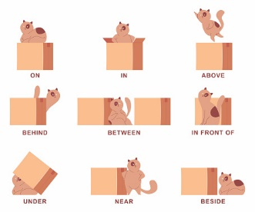
- Prepositions (it is all about vocabulary, seeing and doing/acting out the words.)
- Stuffed toys: over/under/next too/behind
- Table and chairs
- Stand in front/ behind/ in between
- Hide behind etc
- Climb up ladder
- Colour/shape (match / identify and name colours and shapes)
- Identify shape and colour when you are out and about
- What colour shorts/ shirts/ shoes are you wearing etc
- What colour is your favourite
- Cup, toy etc
- I spy colours etc

- Patterning
- Letters/numbers
- Identify starting sounds of words
- Play I spy (colour, shape, sounds)
- Please don’t teach them to write in upper case. All words except the first letter of their name must be lower case
- Identify numbers 1-5 younger groups /1-10 older groups
- Describing (language use)
- Describe your pet, favourite toy, wild animals, food etc
- Play a game where you describe an object and they guess what it is.
- Play a game where you describe something without the object, and they guess etc.
- Use all the senses to describe something
- Ordering by size
- Rhyming (explain what they are and what they mean/ use their stories/ songs/ chants)
- Learn nursery rhymes
- Make up silly rhyming words
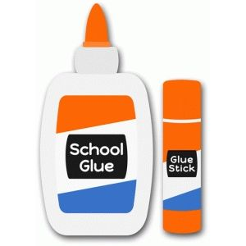
Crafts
- Collages: Glue anything onto a different surface
- Items from nature
- Buttons beads/ paper/magazines pictures torn or cut/ old greeting cards/ newspaper/ wrapping paper/ stickers
- Painting: (poster paint/ mud/ food colouring)
- Use thick and thin brushes/ feathers/ sticks/toothbrushes/ anything you can think of
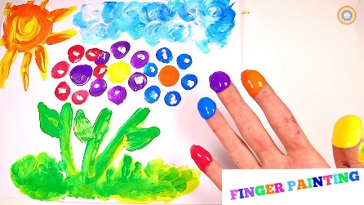
- Paint onto paper/ newspaper/ stones/ driveway etc
- Painting pebbles and hide them for someone else to find
- Sand/ playdough/ slime/ moon dough (find recipes on the web)
- Make a sand tray in a baking tray/ box (wet or dry sand)
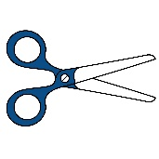
- Threading: (straws/ beads/cereal/ dog biscuits/ pasta etc)
- Cutting: (see attached addendum A)
- straight lines, around shapes, cut out pictures from magazines, thin and thick paper/ cardboard etc)
Movement
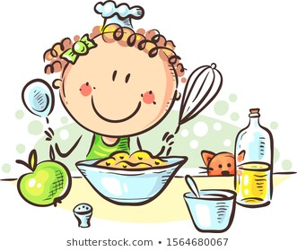
See attached GET MOVING TODAY activity calendar
Cooking
Use different methods: oven, stove, microwave etc
- help prepare supper, vegetables
- follow recipes
- fruit salad
- talk about wet and dry ingredients
- learn to follow a recipe
- talk about measuring/ pouring/ stirring/ rolling/ mixing/spreading kneading etc
- Bake bread together and watch it rise

Story time
- READ to your children.
- Make up your own stories
- Use story cards
- Ask open ended questions about the story as well as content-based ones.
- Let children ask you questions about a specific topic

Games
- Don’t emphasise the winning and losing but play until everyone has finished
- E.g.: snakes and ladders/ memory games/ UNO/ Ludo etc
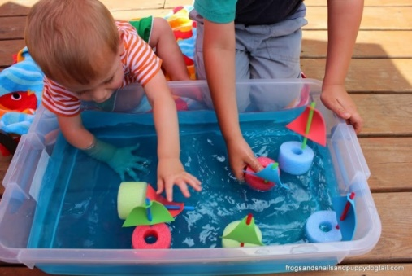
Outdoor
See attached GET MOVING TODAY activity calendar
- Build tents
- Piggy in the middle
- Hopscotch
- Wolfie, wolfie what’s the time
- All ball games
- Water play (bubbles, coloured water, empty bottles, floating and sinking)
- Gardening

Help with daily chores
- Washing, sweeping, vacuuming, folding, packing away, making beds etc.

Try being as innovative as possible. Use recycling and what you find at home, you do not need to spend lots of money.

